**User story of ATS**

**History Card**

|  |  |  |  |
| --- | --- | --- | --- |
| **Version#** | **Modification History** | **Update Date** | **Created/Reviewed by** |
| 1.0 | Prepared User Story | 30 April 2017 | Md. Aftab Uddin Kajal |
| 1.1 | Writ up Story | 3 May 2017 | Md. Aftab Uddin Kajal |
| 2.0 | Design Mockup | 7 May 2017 | Md. Aftab Uddin Kajal |
| 2.1 | First review | 08 May 2017 | Md. Mahedee Hasan |
| 2.2 | Some Modification | 10 May 2017 | Md. Aftab Uddin Kajal |
| 2.3 | Some Modification | 20 May 2017 | Md. Aftab Uddin Kajal |
| 3.0 | Final Modification | 29 May 2017 | Md. Aftab Uddin Kajal |

Table of Contents

Project Name 2

Team Name 2

Team Members 2

Submitted to 3

Project Description 3

Current Scope 3

Future Work 3

User story 3

1. System Settings 3

1.1 Organization Setup 3

1.2 Branch Setup 4

1.3 Add Employee 5

1.4 Add Department 6

2. Asset Setup 7

2.1 General Category Setup 7

2.2 Category Setup 8

2.3 Sub Category Setup 8

2.4 Product Category Setup 9

2.5 Categories 9

2.6 Manufacturer Setup 10

3. Asset Management 10

3.1 Asset Purchase Entry 10

3.2 Asset Registration 12

3.3 Asset Transfer 14

3.4 Asset Receive 15

3.5 Asset Transfer Cancel 16

3.6 Asset Distribution 16

3.7 Asset List 17

4. User Management 18

4.1 User Setup 18

4.2 User Role Setup 18

4.3 User wise Role Setup 18

4.4 Role permission for Menu Setup 18

5. User Dashboard 19

6. Admin Dashboard 20

7. Reporting 21

7.1 Asset List Report 21

7.2 Location wise Asset Report 22

7.3 Asset Tracking History 23

7.4 Warranty Tracking Report 24

References 24

# Project Name

* Asset Tracking System(ATS)

# Team Name

* Single Bit

# Team Members

|  |  |  |  |
| --- | --- | --- | --- |
| SL# | Name | Email | Contact Number |
| 1 | Md. Aftab Uddin Kajal | [kajal.alpha@gmail.com](mailto:kajal.alpha@gmail.com) | 01717839097 |

# Submitted to

|  |  |  |  |
| --- | --- | --- | --- |
| SL# | Name | Email | Contact Number |
| 1 | Md. Mahedee Hasan | [Mahedee.hasan@gmail.com](mailto:Mahedee.hasan@gmail.com) |  |

# Project Description

Asset Tracking Systems known as ATS is a web based application to automate company’s Asset related activity. This system is for asset management and tracking for an organization. organization has various branches (i.e. DHK, CTG) which it distributes various assets (Table, Chair, Desktop, Laptop, Server etc.) also Private organization has to manage its own asset and Private organization organizes various events regarding which Private organization has to purchase assets.

It's difficult to manage this asset and tracking the assets.

# Current Scope

Our current scope is to develop Asset Tracking System known as ATS and relevant configuration setup interfaces.

# Future Work

We will develop Varcode System, Dashboard, Directory, Security (Authentication and authorization) etc.

# User story

|  |  |
| --- | --- |
| **SL#** | **Story Name** |
| 1 | System settings |
| 2 | Asset Setup |
| 3 | Asset Management |
| 4 | User Management |
| 5 | User Dashboard |
| 6 | Admin Dashboard |
| 7 | Reports |

## System Settings

### 1.1 Organization Setup

In this setup page user will setup organization, Name, Phone, Fax, Email, web, Address and About.

After saving the information, organization Information will be displayed as a summary information.

(See Mock for this feature in the mock: Organization Setup.)

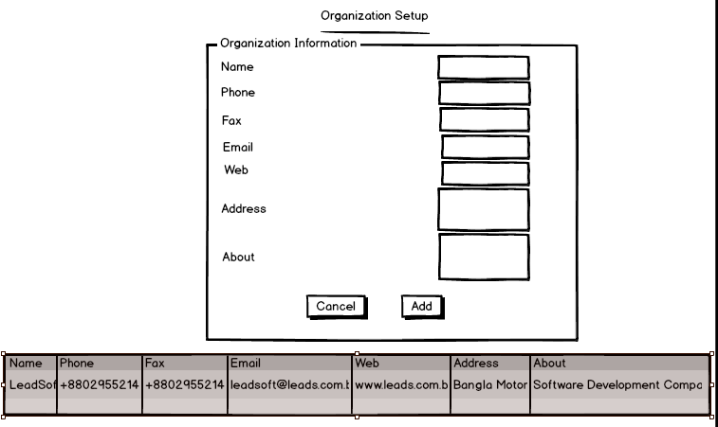

### 1.2 Branch Setup

In this setup page user will setup Branch for organization, where Branch Information will Branch Name, Branch Code, Phone, Fax, Email, Address.

* Branch name example “Leadsoft Dhaka Office”.
* Branch Code example “L-DHK”.
* Phone example 123.
* Fax example 123
* Email example [dhakaoffice@leads.com.bd](mailto:dhakaoffice@leads.com.bd)
* Address example Banglamotor

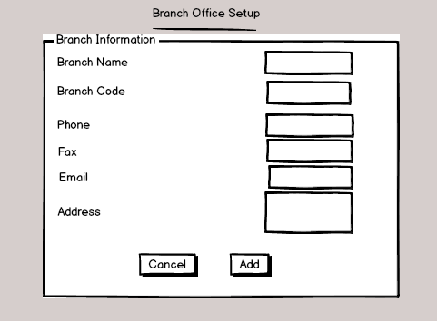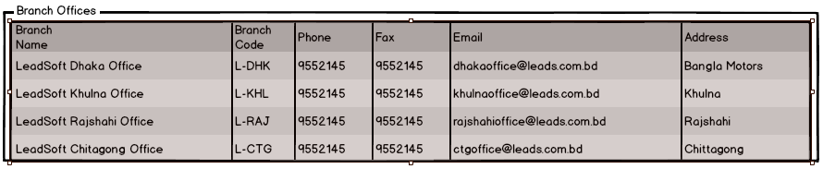

### 1.3 Add Employee

User can Add an Employee as like following figure.

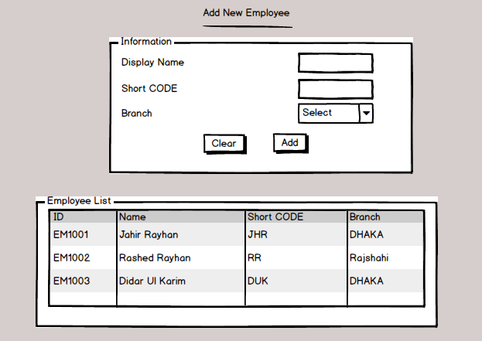

### 1.4 Add Department

User can Add Department as like following figure.

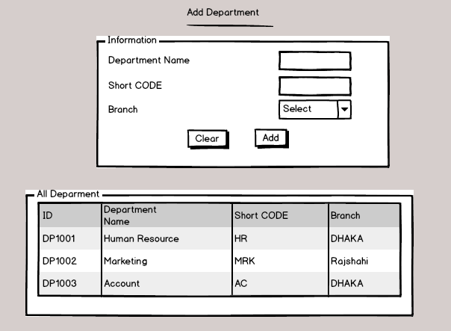

## Asset Setup

### General Category Setup

In this configuration page user will setup general category which represents the general category of the asset, user will further register assets by selecting its general category.

In this page user will provide General Category Name and Description.

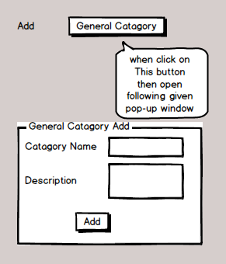

### Category Setup

In this configuration page user will setup their category which will be used to identify assets

Category under specific general category.

In this page user will select General Category from dropdown which is mandatory, Name and description of category.

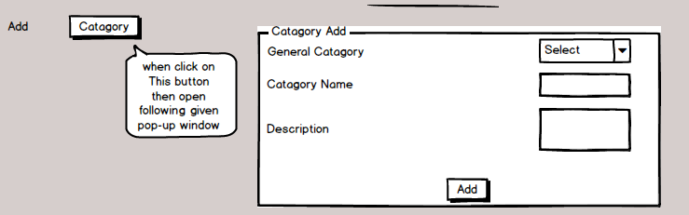

### Sub Category Setup

In this configuration page user will setup their Sub category which will be used to identify assets under Category and specific general category.

In this page user will select General Category and Catagory from dropdown which is mandatory, Name and description of category.

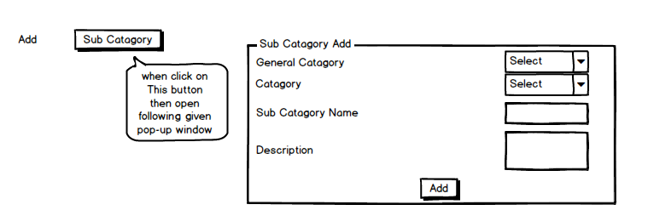

### Product Category Setup

In this configuration page user will setup their category which will be used to identify assets

Category under specific general category, Category and Sub Catagory.

In this page user will select General Category, Category and Sub Catagory from dropdown which is mandatory, Name and description of category.

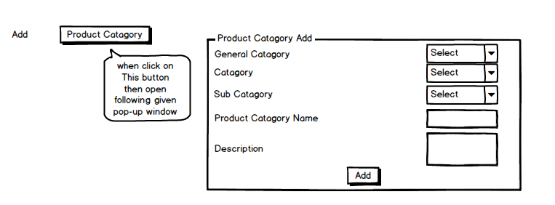

### Categories

In this page user will See all categories. In this page all item will editable. When user click on name it gives pop-up menu as like as Product category setup picture.

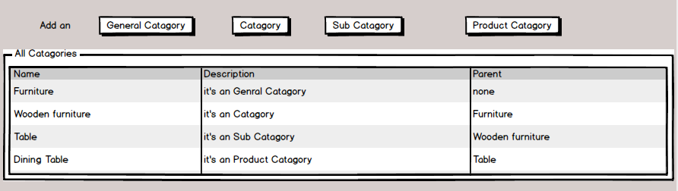

### Manufacturer Setup

In this Page user will setup Manufacturer/vendor/supplier information.

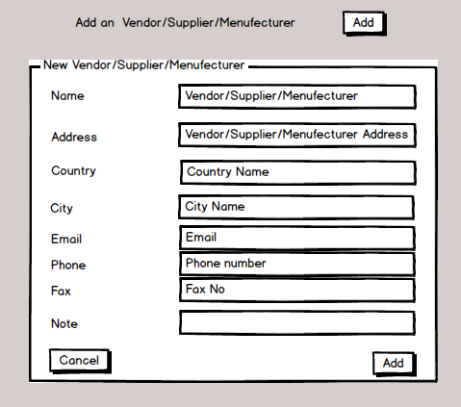

Figure when user Click on Add Button add "New Vendor/Supplier/Menufecturer" will open with pop-up menu

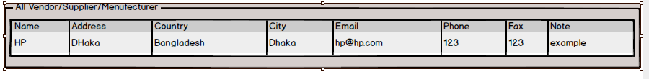

## Asset Management

### Asset Purchase Entry

User wants to keep record of purchase history of assets, so they can.

In this page user will give input name, purchase date, vendor information etc.

For asset, user will select asset general category, category, sub-category, model, warranty period(if any), price, qty(default 1), serial no(optional), after that user will click on add button to add assets, if qty is more than 1 and serial no is provided then a pop-up screen will appear to enter the serial no of all assets. then asset information will be added to the list.

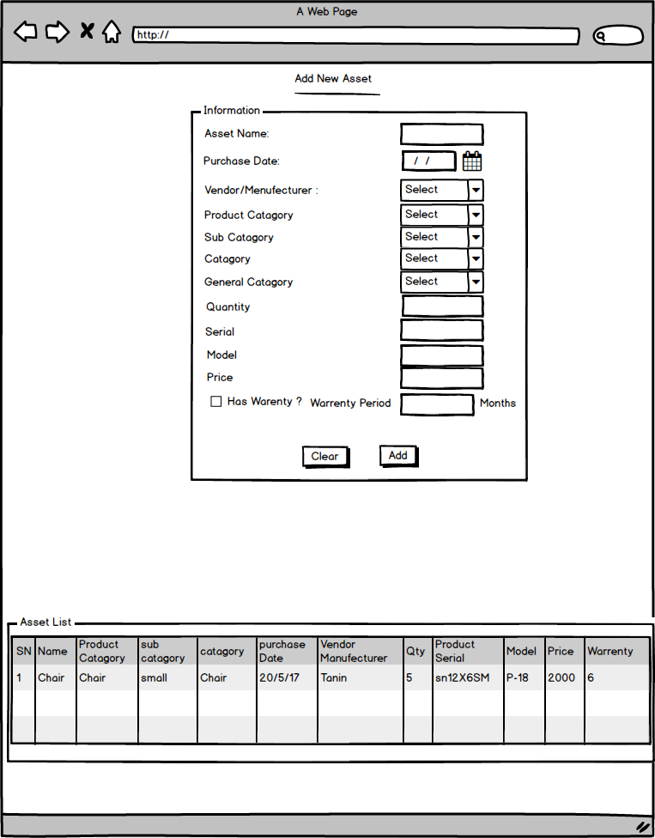

Finally, on save action, the information will be saved as a purchase record, further user will be able to see this record by purchase report (date range wise). Assets' status will be [unregistered] as the asset id is not generated for purchased item yet.

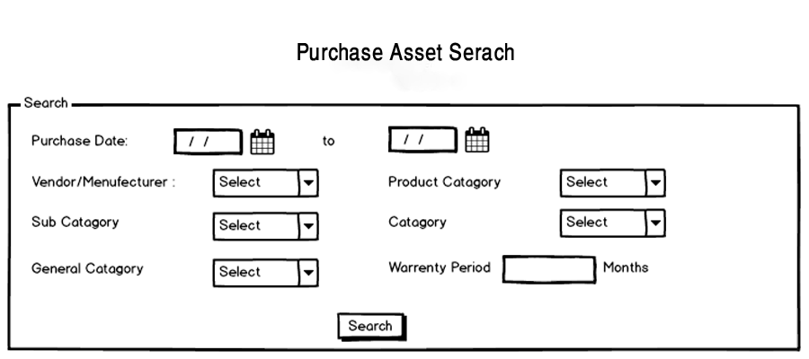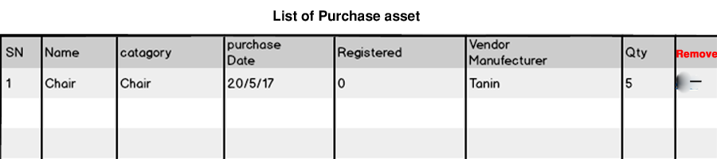

### Asset Registration

In this page user will register [unregistered] assets by searching them and selecting them. by asset category asset ID will be generated.

Asset Registration Means after purchased asset and then need to make registration. Then registered all asset will use. First mockup for new asset and second mockup for existing asset.

In this page asset will be set with its location while generating its ID.

Asset ID format would be [GeneralCategoryCode][CategoryCode][6 digit numeric]

example, CEMON000001 - [Computer Equipments][Monitor][000001]

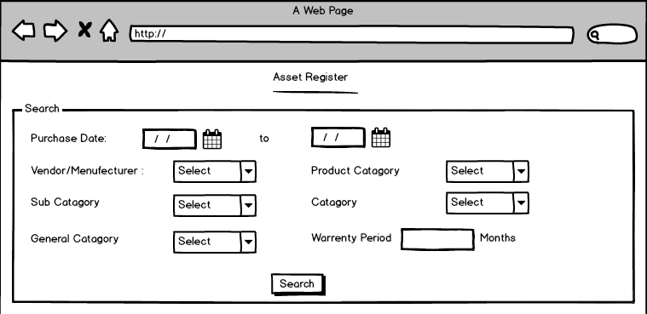

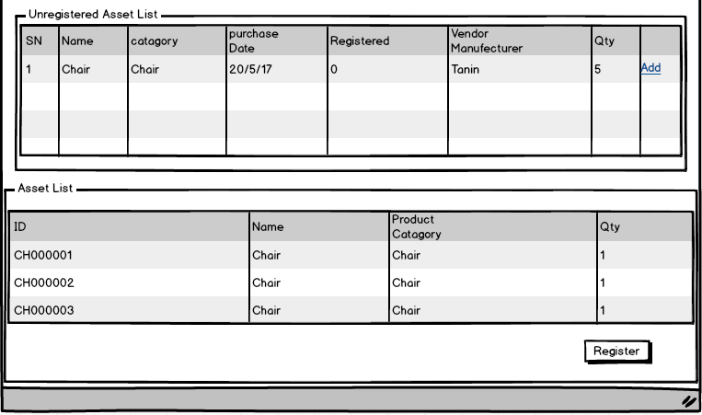

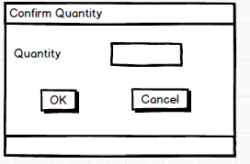

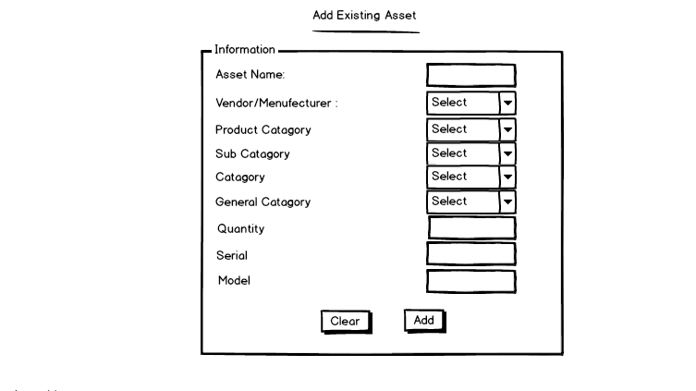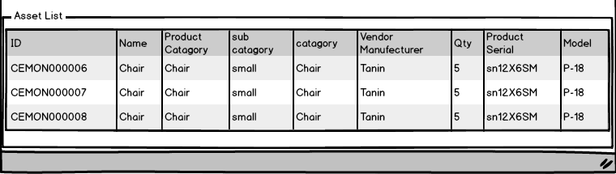

### Asset Transfer

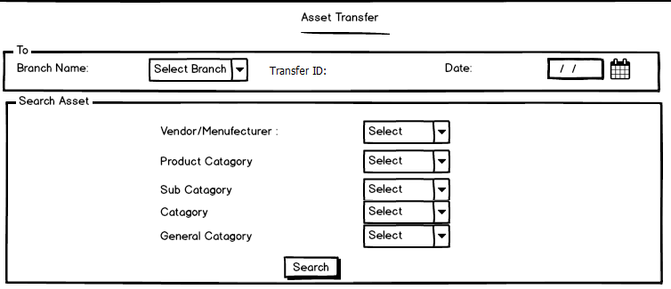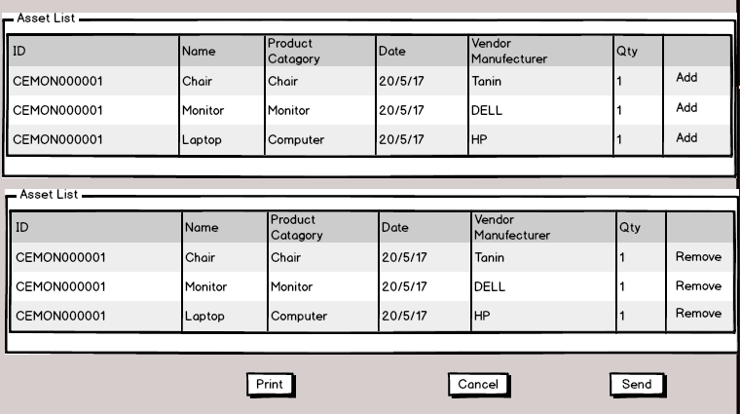

Asset can be moved from location of one branch/organization to location of another branch or organization, here user will select destination and search and select for assets, and confirm movement of assets from one location to another, then status of asset would be 'on movement from [source] to [destination]'

After movement entry, movement challan will be generated and user will be able to search for movement entry for his branches moved assets status.

### Asset Receive

Asset must be received to be part of the location, until then status of the asset would be on movement, after receiving of the asset the asset would be for the location and status would be 'on [location name]' . Here appro al Means Accept

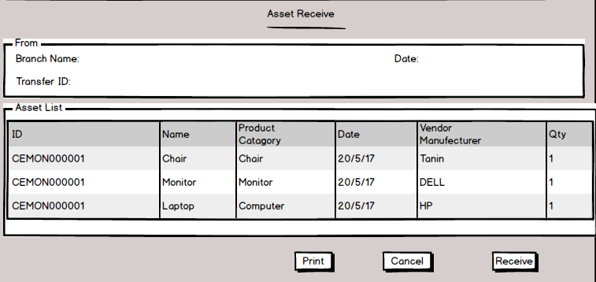

### Asset Transfer Cancel

Asset Transfer can be cancelled by sender before receiving to a location. Follow Asset transfer picture.

### Asset Distribution

Asset Distribution/Assign can be done for various type (Department, Employee) in this page user will select distribution/Assign type and can distribute asset to a particular employee or to a particular Department.

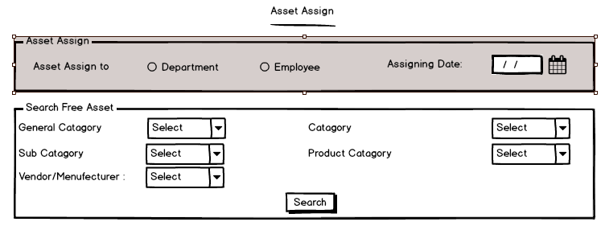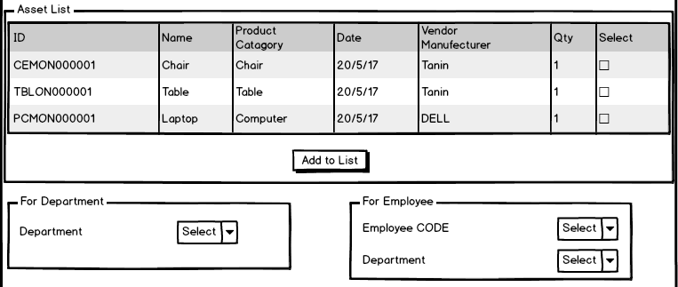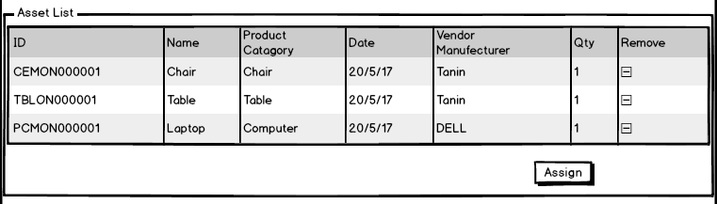

Department distribution can be done on assets on same branch, to be precise, asset cannot be distributed to another branch, for this user has to use asset movement entry page.

### Asset List

User can view Asset list as like following figure.

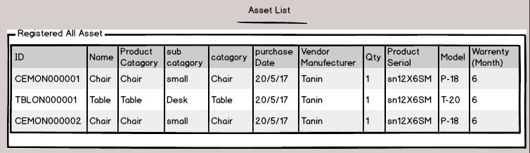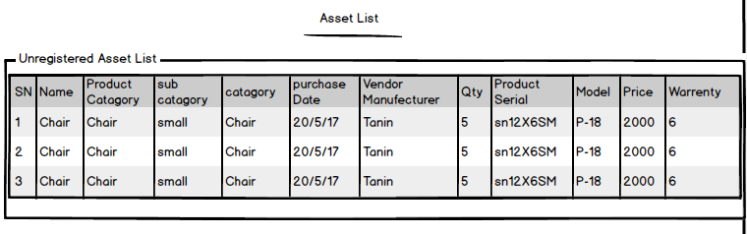

## User Management

### User Setup

This page is for user registration, providing user name, full name, organization, designation

### User Role Setup

This page is for Role setup. Where role name will be provided.

### User wise Role Setup

In this page user and its role will be assigned. If the user already assigned particular roles the roles will be selected and roles can be updated further.

### Role permission for Menu Setup

Menu can be setup by selecting parent menu.

Role wise menu can be assigned, here all menu information will be shown and role wise menu can be set, while user will login in the system, unique menu will be generated by set permission (as a user can have multiple roles, so menu can be overlapped, the case should be considered).

## User Dashboard

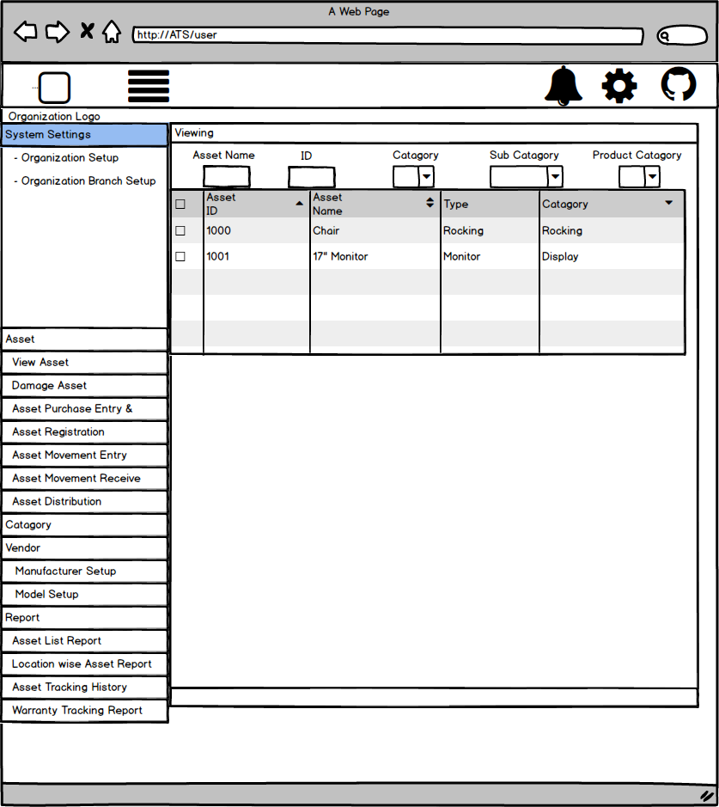

## Admin Dashboard

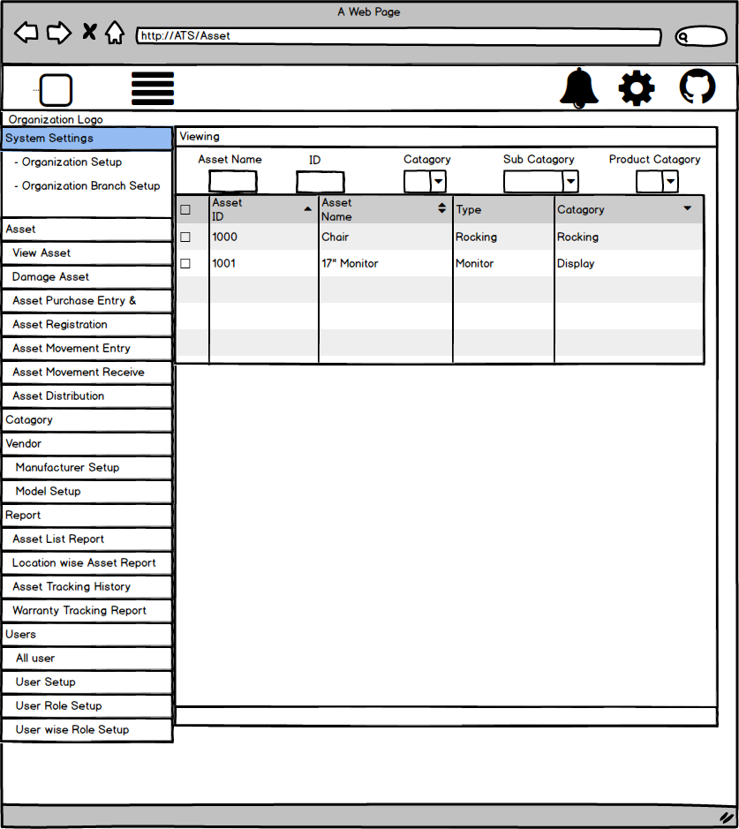

## Reporting

### Asset List Report

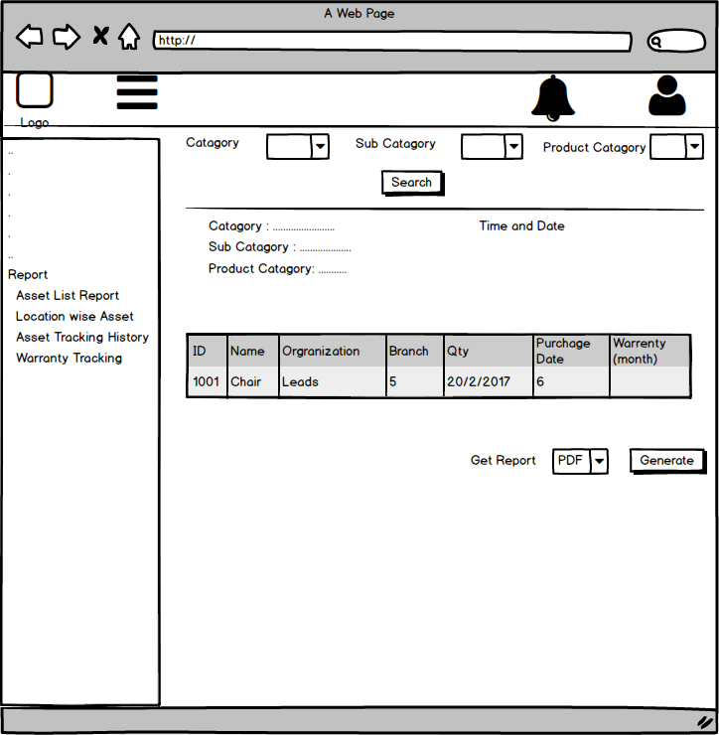

### Location wise Asset Report

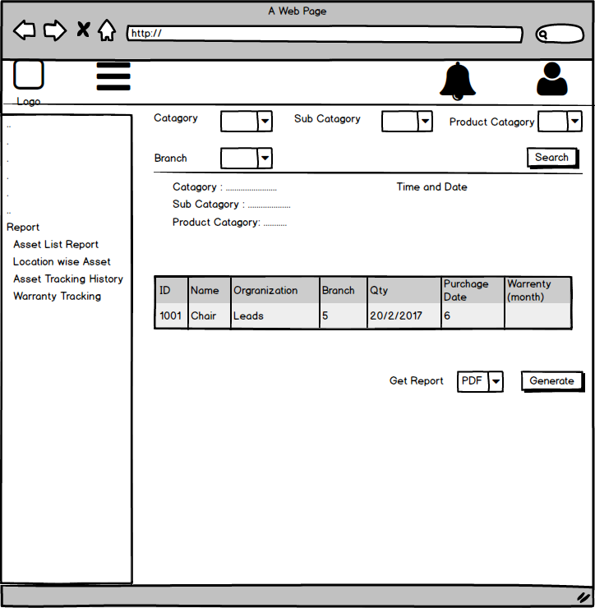

### Asset Tracking History

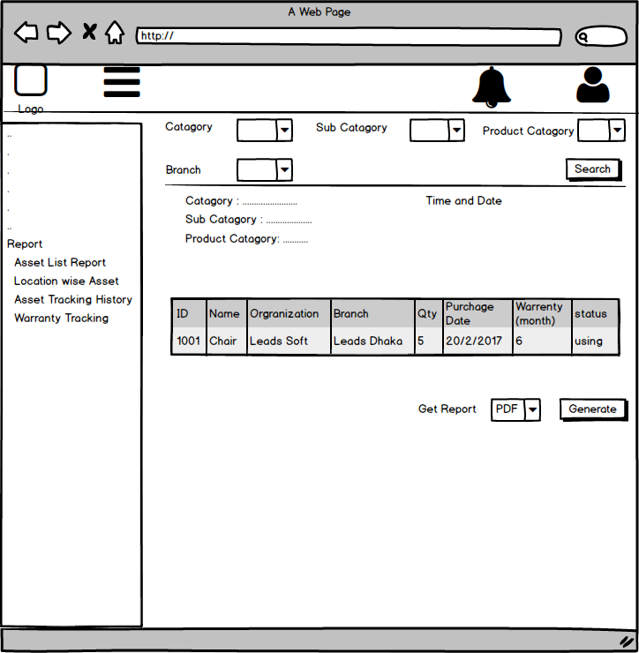

### Warranty Tracking Report

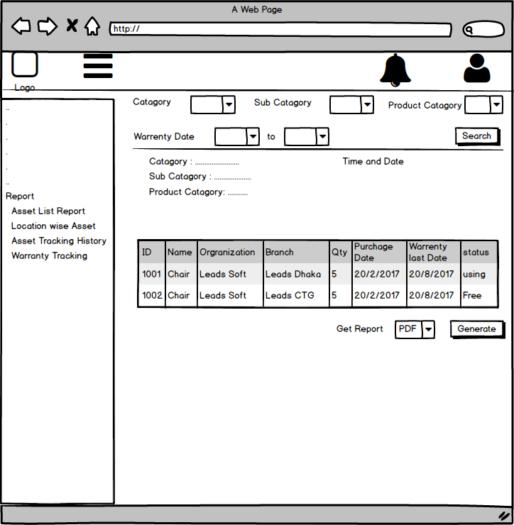

# References

1. <https://www.waspbarcode.com>
2. <https://freshservice.com/it-asset-management-software>